Software Development Unit 3, 3.7

Anna Legaspi

# I can select and join networks and data feeds to manage data to suit collaborative tasks

## RSS

A decade ago, I used to have an RSS reader which allowed me to list all the bloggers that I wanted to follow. Whenever any of the listed bloggers had a new post, I would get the post to display in my RSS reader such as [Feedly](https://feedly.com/). This made it easier to collate all of the unread posts from various blogs as it was presented to me in one place. I then had the ability to view the posts and click a link that directs me to the original blog if I wanted to comment on any of the posts.

Saying that, RSS readers aren’t as useful nowadays, especially with the rise of better collaborative and social technologies. Nowadays, I can simply follow content creators on YouTube, Instagram, Facebook, etc. From there, I can comment on people’s posts, send direct messages and read other people’s comments too.

## Mailing list

Mailing lists can get a bad reputation since it is closely related to spam mail. However, I have subscribed with some mailing lists, specifically subjects that I’m interested in. For example, I’ve signed up to receive emails from [Succulents and Sunshine](https://www.succulentsandsunshine.com/). I like the tips she sends on how to care for succulents since I care for a few succulents myself. I’ve taken a snippet of my inbox where you can see I’ve labelled and organised some of the emails I’ve received from that specific mailing list.

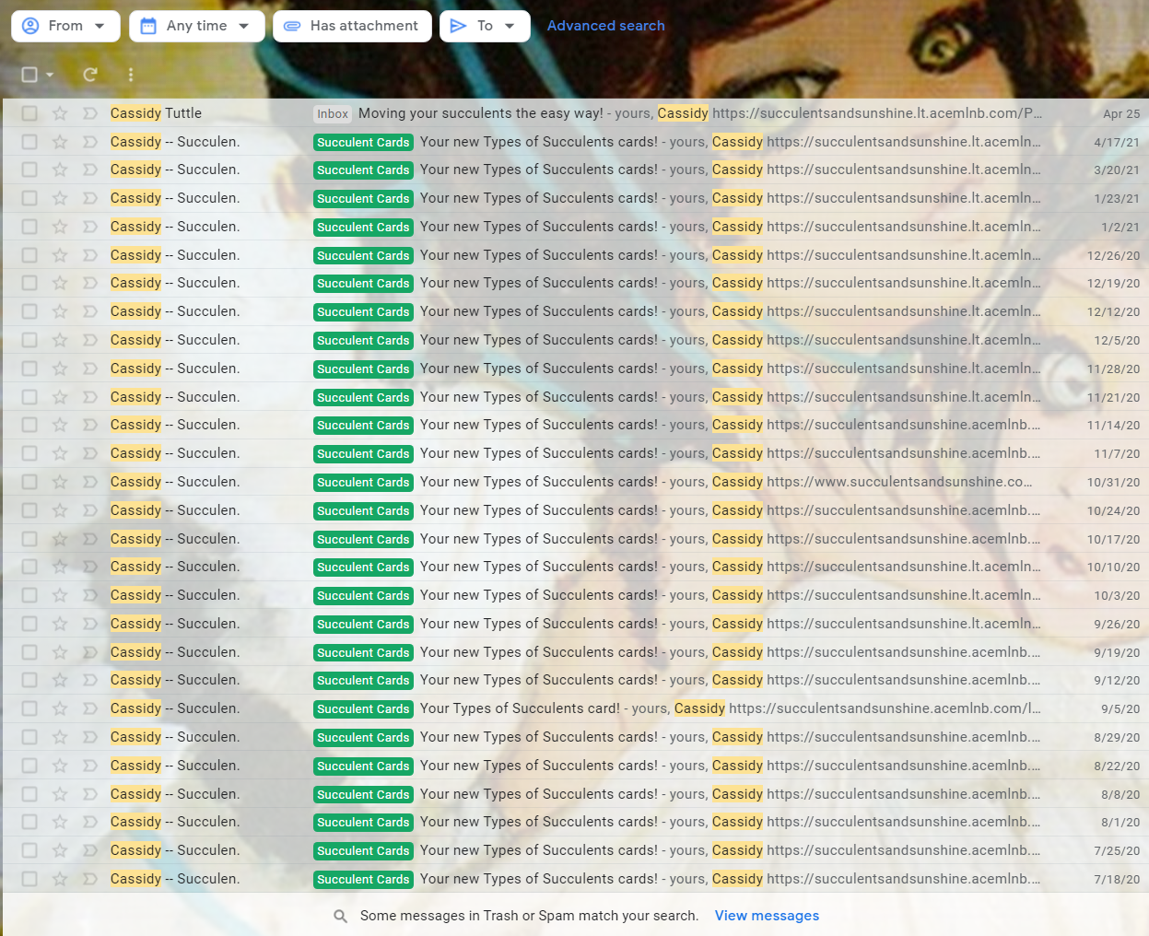

## Forum

I’m also subscribed to a Forum called [ForeverGaming](https://forevergaming.co.uk/forum/), since I also enjoy communicating with my gaming community. In this forum, there is a section for Guides and Tips on how to play certain games. If there are any questions on accessing an online server or game, I can simply put a message on the relevant thread and one of the active members will provide me with answers.

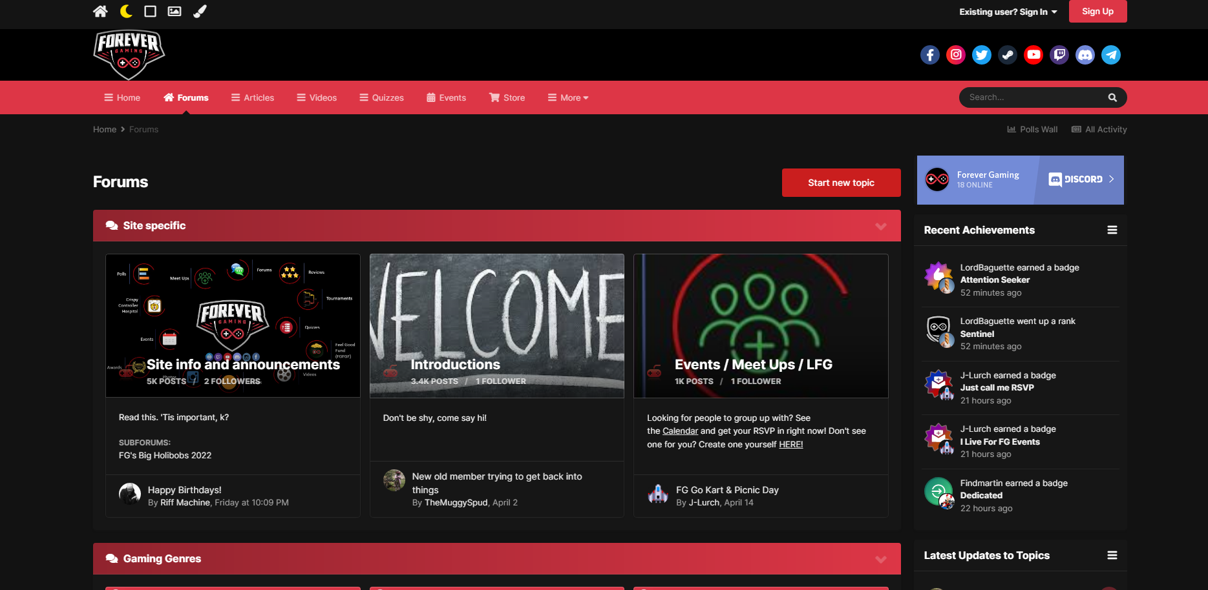

## Mashups

In the world of IT, Mashup is when various sources of information are collated and presented in one website or web application. I can use my place of work as an example for a business Mashup. I work as a UAT tester for my current company. Our company, CBS, owns a website and we want to have a functionality that allows better accessibility to our customers. CBS made an agreement with a third-party company who can do this. Before this can be implemented, the accessibility functionality needs to be integrated, tested and deployed in our website to confirm it works as intended. In the heart of this, all software developers, UAT Analysts, Devs, ST and UAT testers have access to Jira. Jira is the web service that we use to log all defects and bugs which is allocated to the relevant department who can assist in resolving the issues.